Ta Quang Tung – 104222196

COS20019 – Cloud Computing Architecture - Wk9: ACA Module 13 Challenge Lab - Implementing a Serverless Architecture for the Café

**Task 1 - Downloading the source code**

Code .zip files are downloaded from Canvas.

**Task 2 - Creating the DataExtractor Lambda function in the VPC**

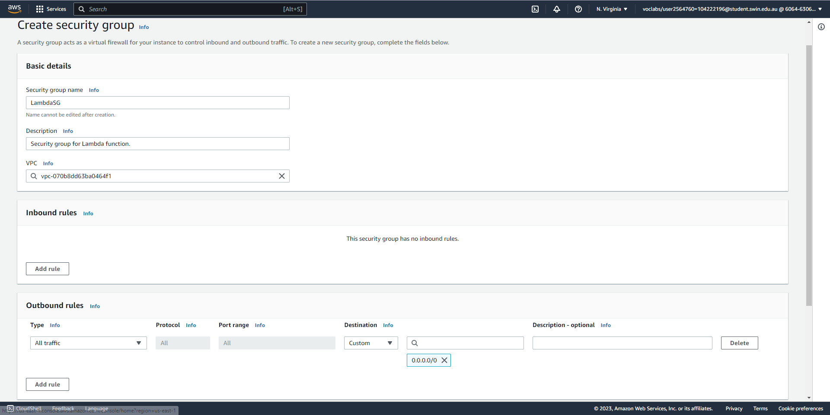

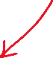

Create a security group for the Lambda function that allows all outbound traffic to all destinations.

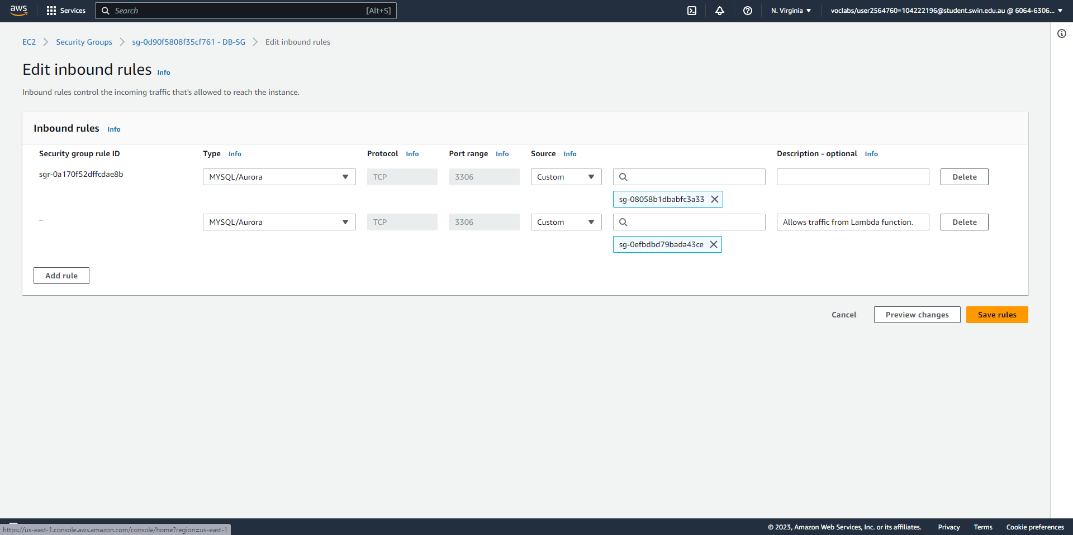



Update the Database SG to allow MySQL traffic from the Lambda function.

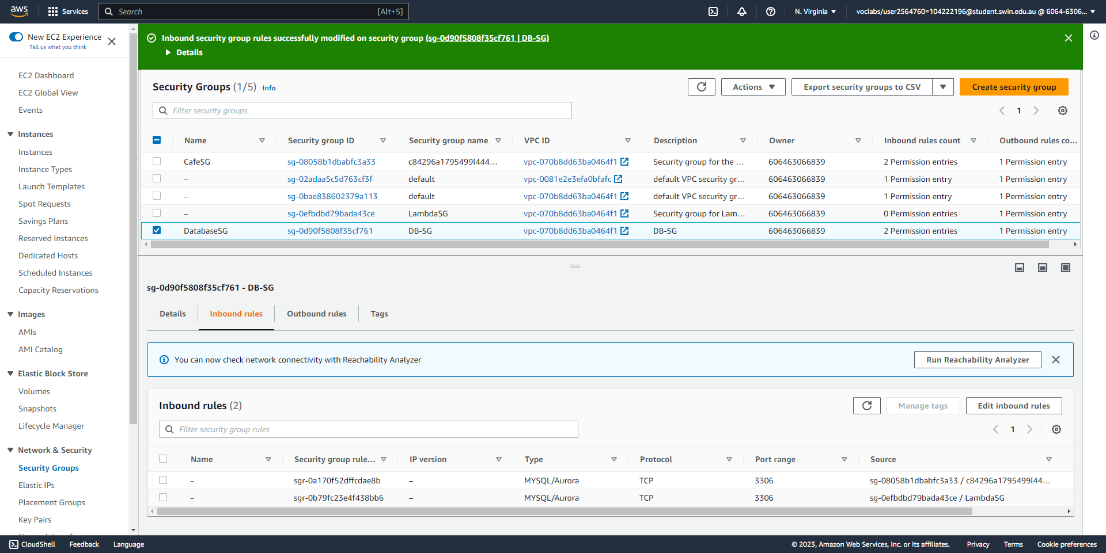



The security group has been successfully updated.

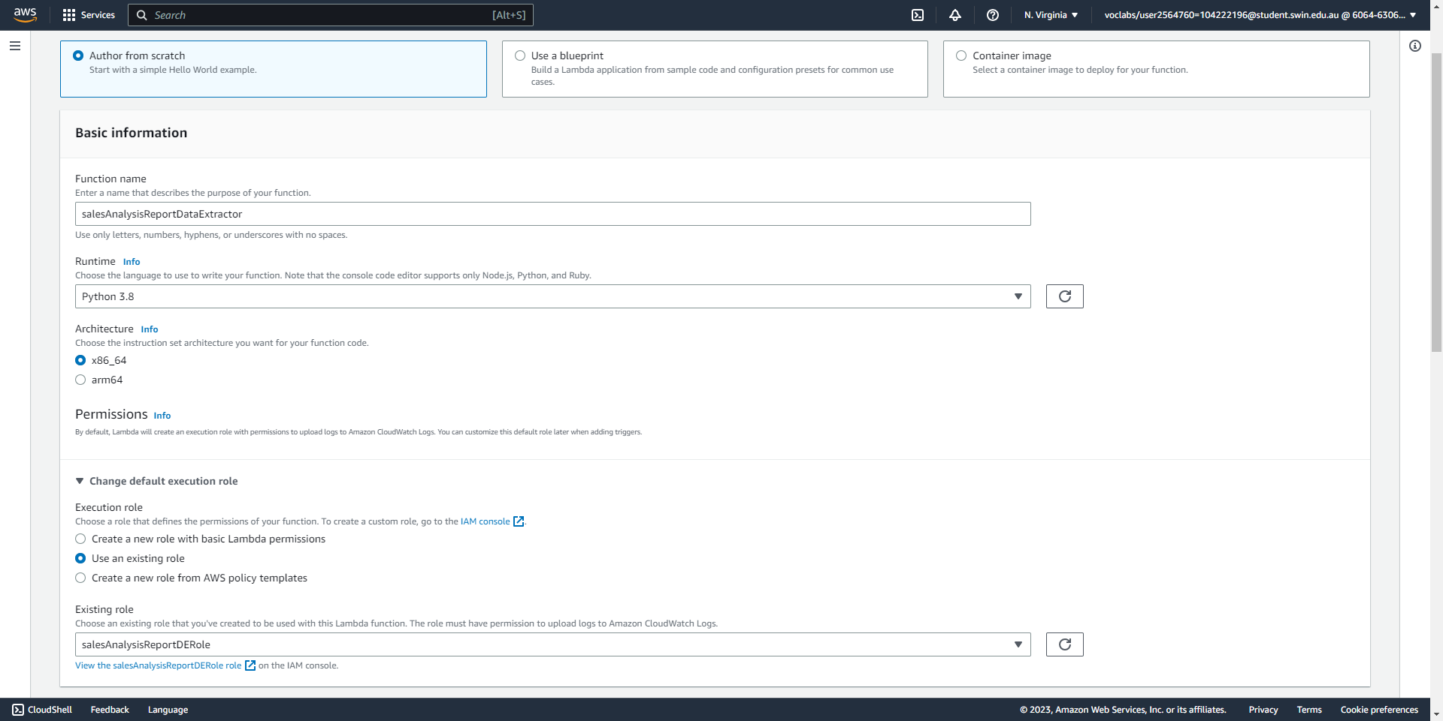



Create the Data Extractor Lambda function (part 1/2), specifying the correct name, runtime, and IAM role.

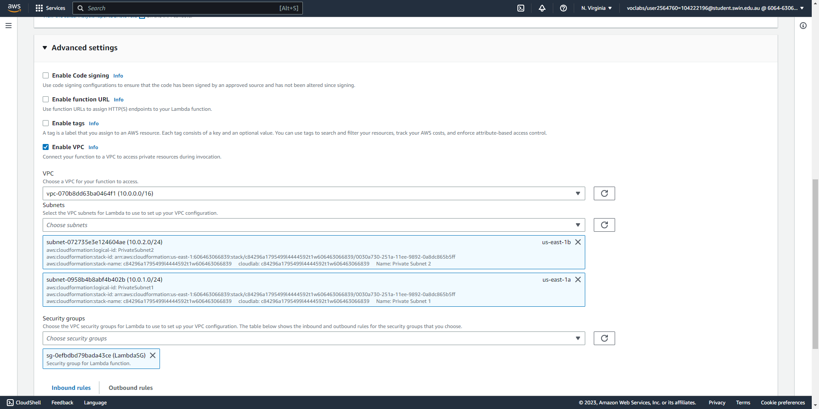



Create the Data Extractor Lambda function (part 2/2), specifying the correct VPC settings.

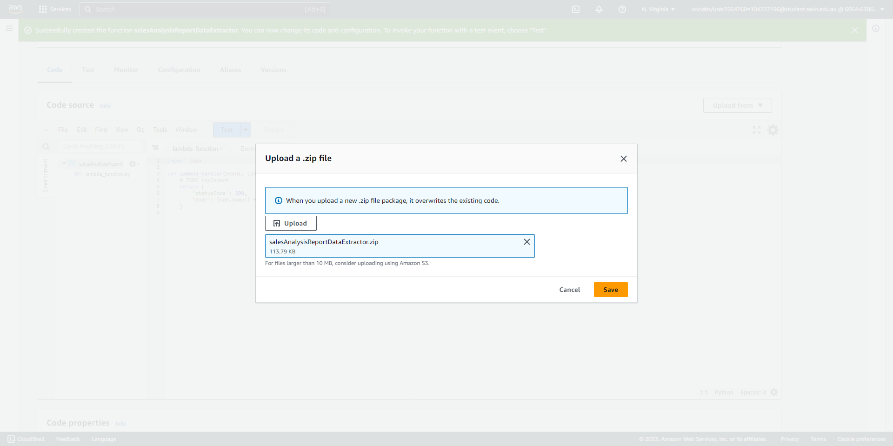



Upload the zipped code for the Data Extractor function.

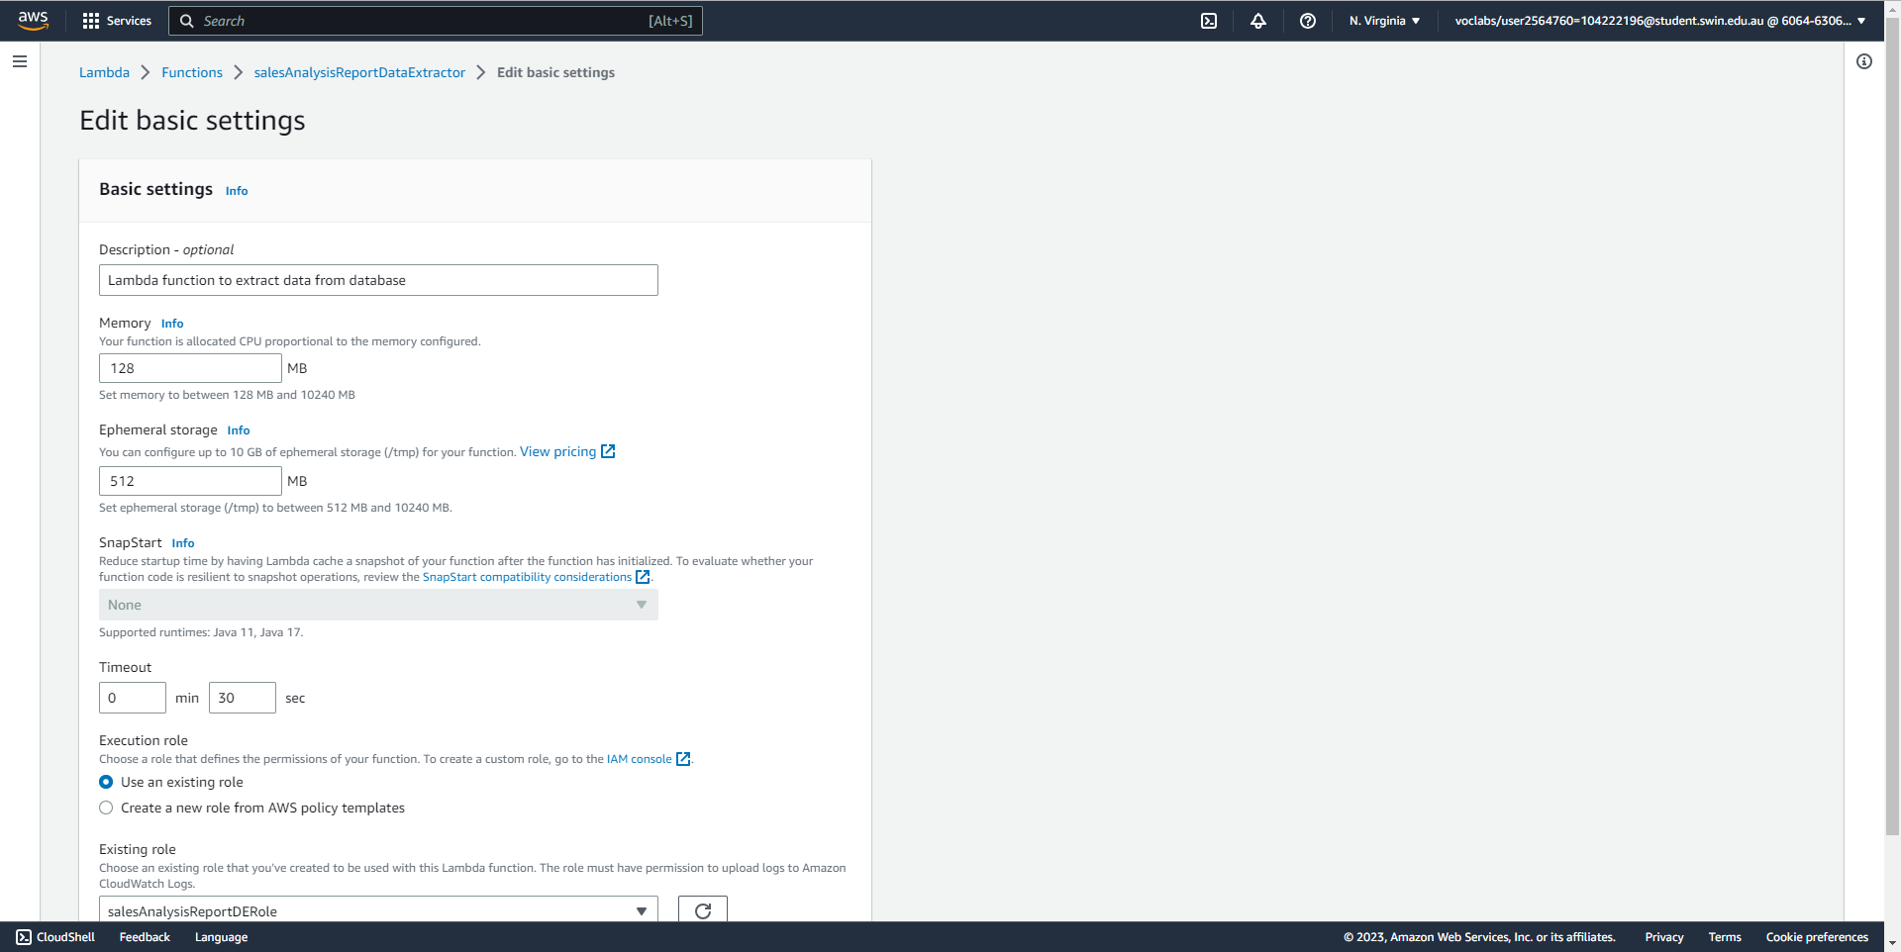



Configure the description, memory size and timeout for the Lambda function.

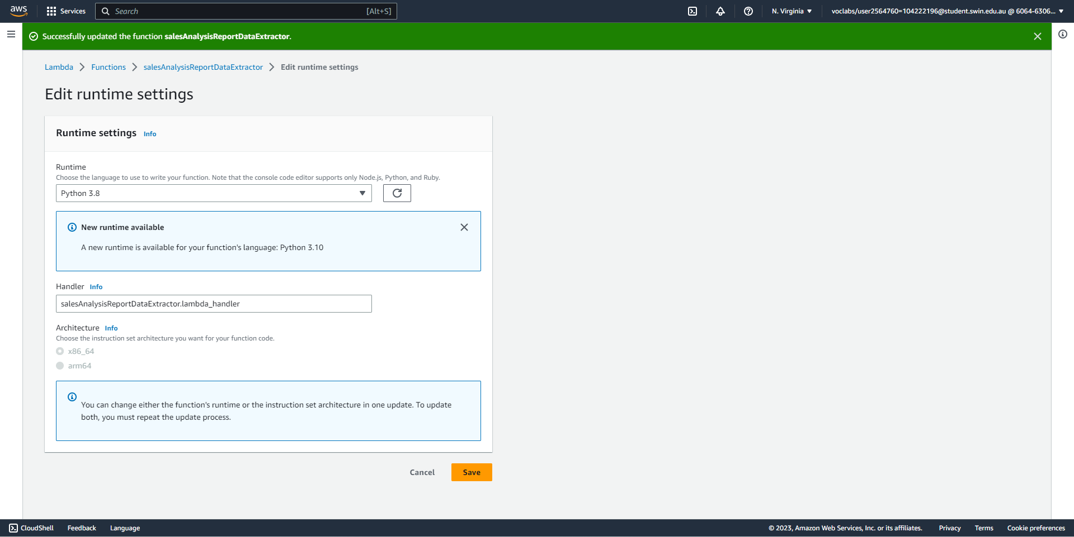



Specify the correct handler for the Lambda function.

**Task 3 - Creating the salesAnalysisReport Lambda function**

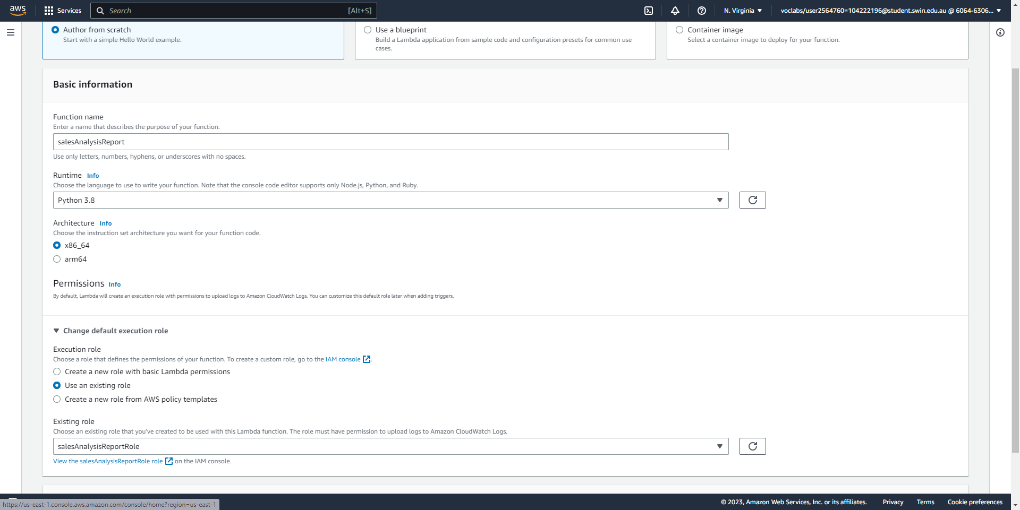



Create the Analysis Report Lambda function, specifying the correct name, runtime, and IAM role.

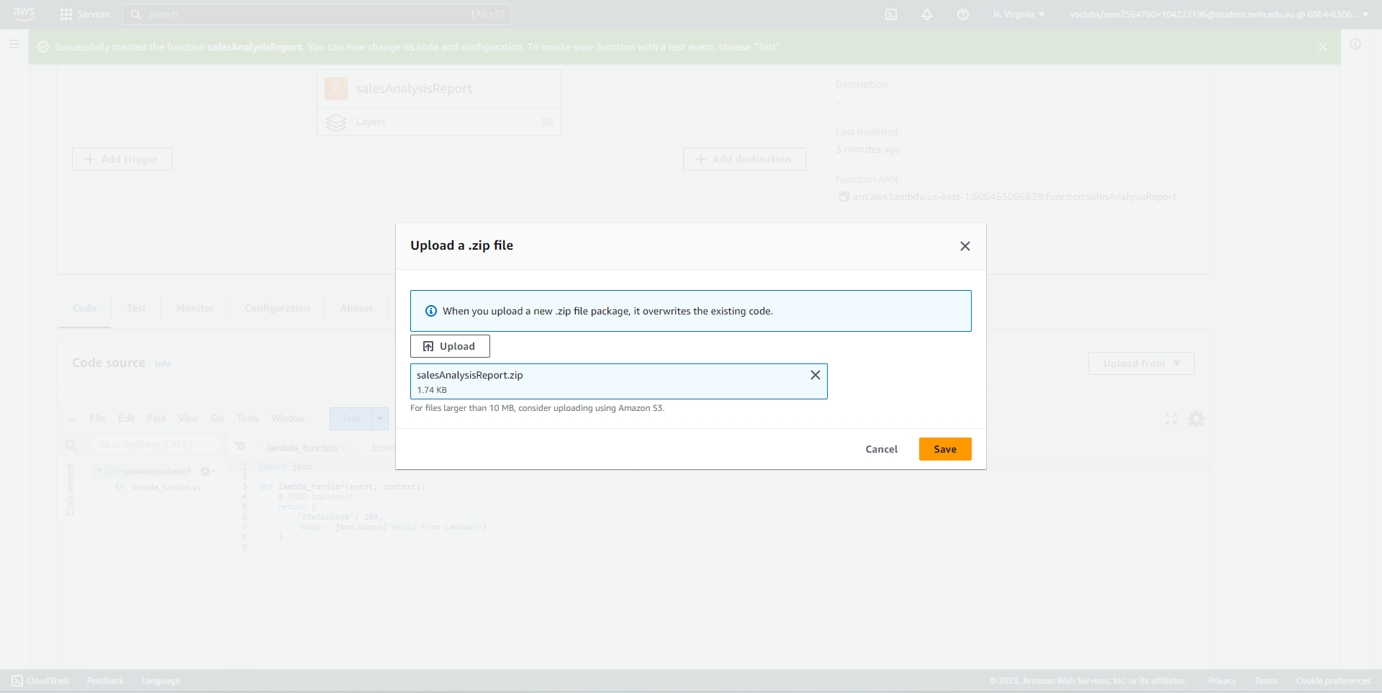



Upload the zipped code for the Lambda function.

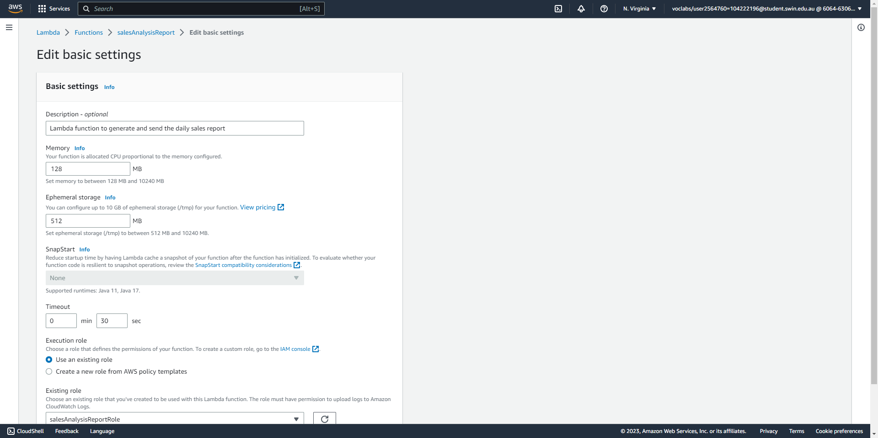



Configure the description, memory size, and timeout for the Lambda function.

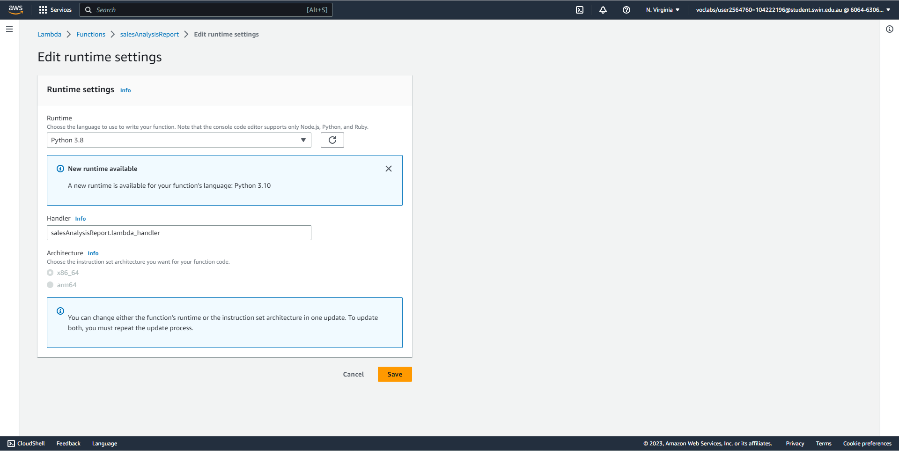



Specify the correct handler for the Lambda function.

**Task 4 - Creating an SNS topic**

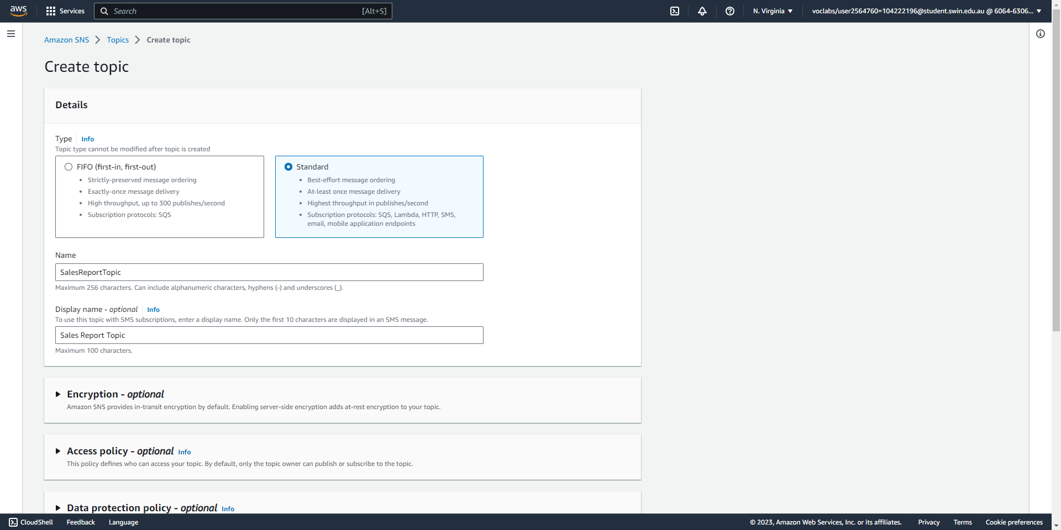



Create a standard SNS topic with the correct name and display name.

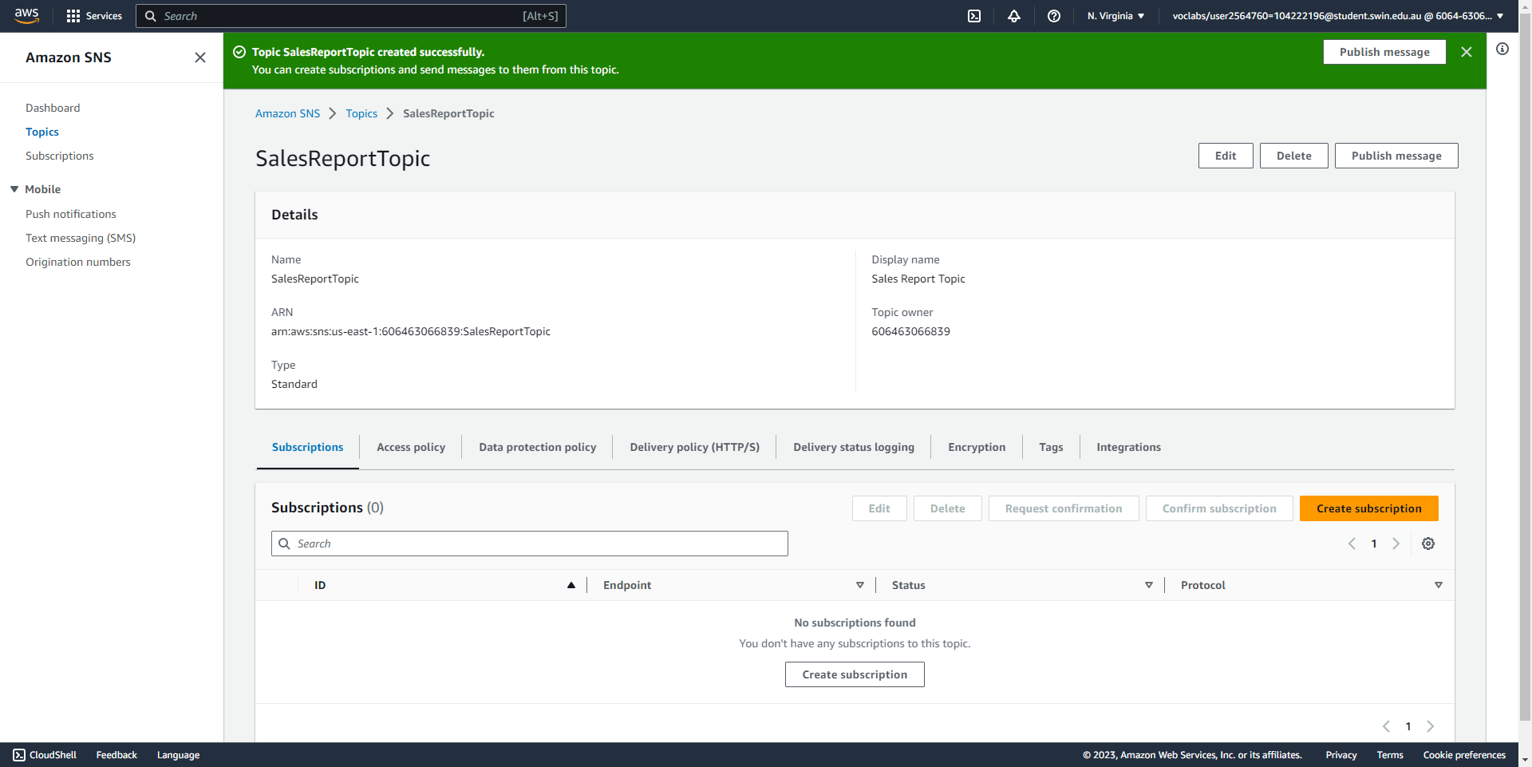



The SNS topic has been created successfully. Its ARN is shown above.

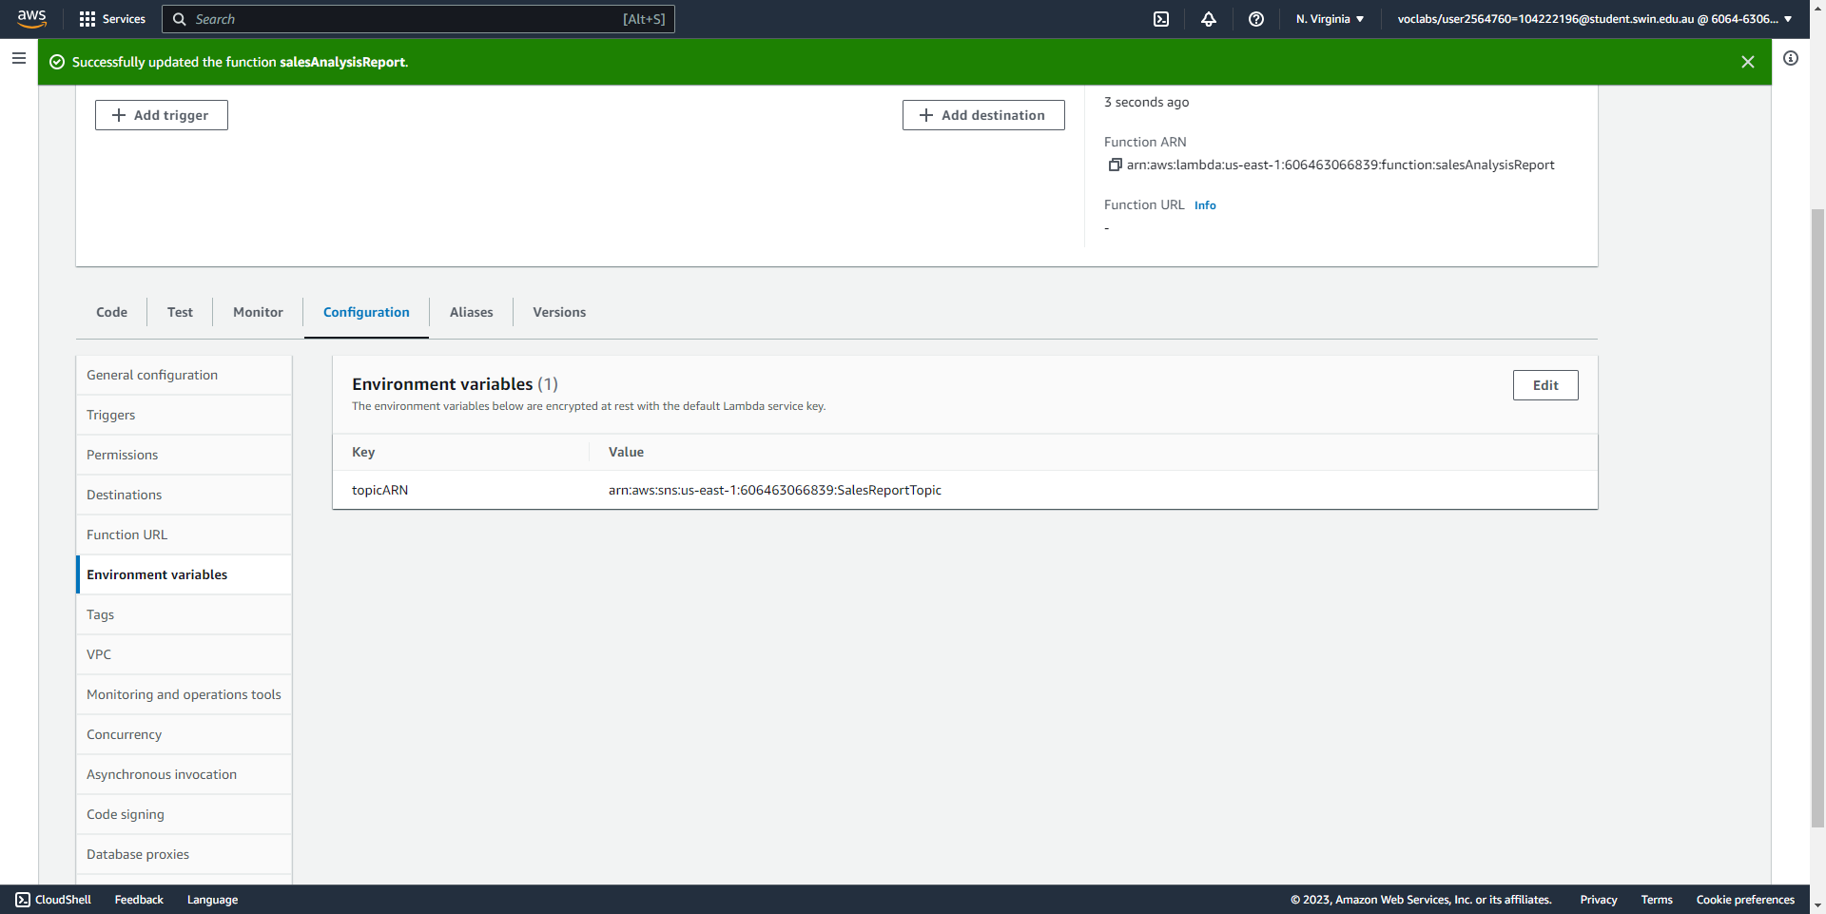



Add an environment variable to the Analysis Report function that references the ARN of the SNS topic.

**Task 5 - Creating an email subscription to the SNS topic**

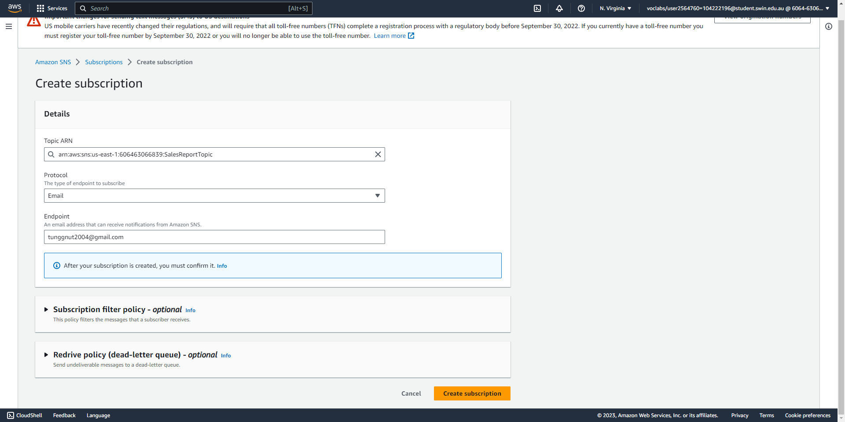



Create an email subscription to the SNS topic.

**Task 6 - Testing the salesAnalysisReport Lambda function**

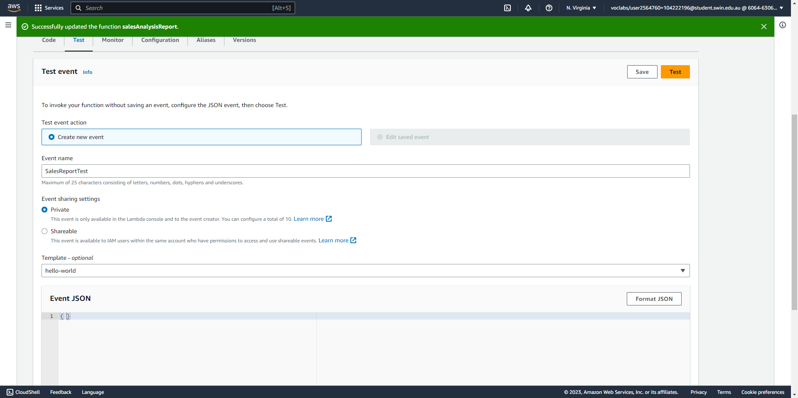

Create a test event for the Analysis Report function.

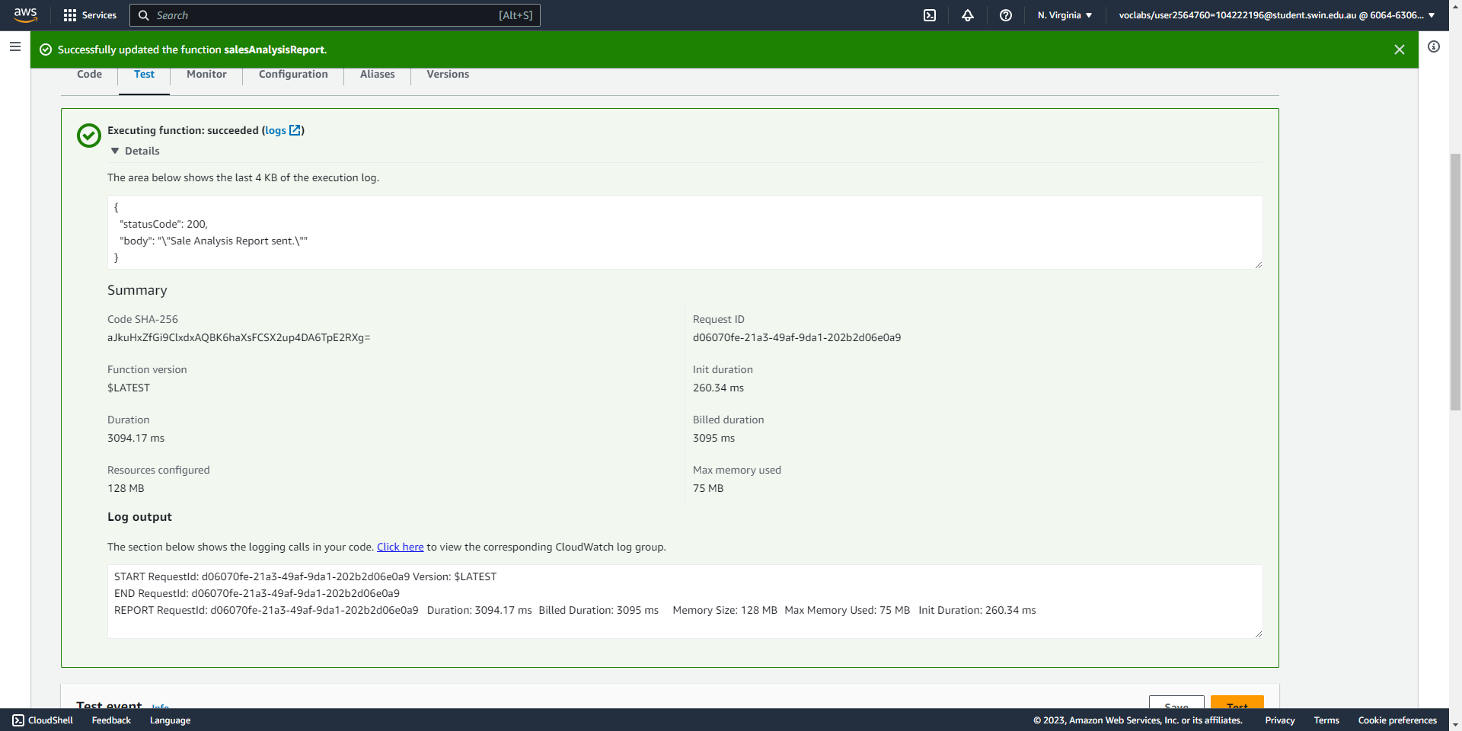

Successfully run the test event.

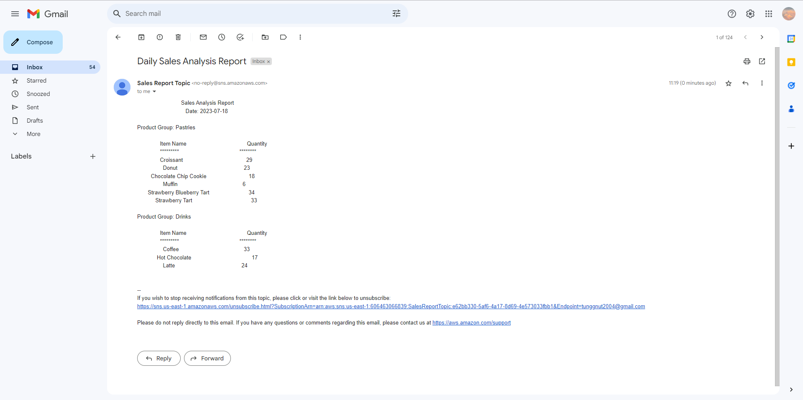

An email report is sent to the subscription email.

**Task 7 - Setting up an Amazon EventBridge event to trigger the Lambda function each day**

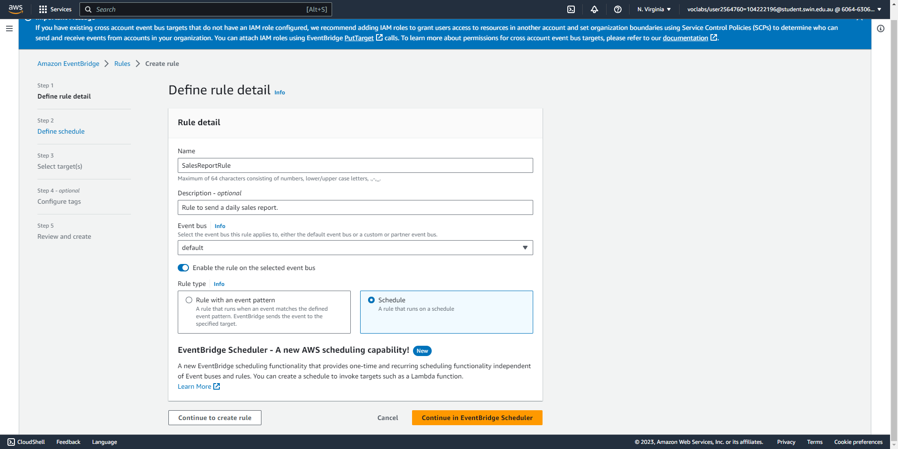



Create an EventBridge event (part 1/3), specifying the name, description, and rule type.

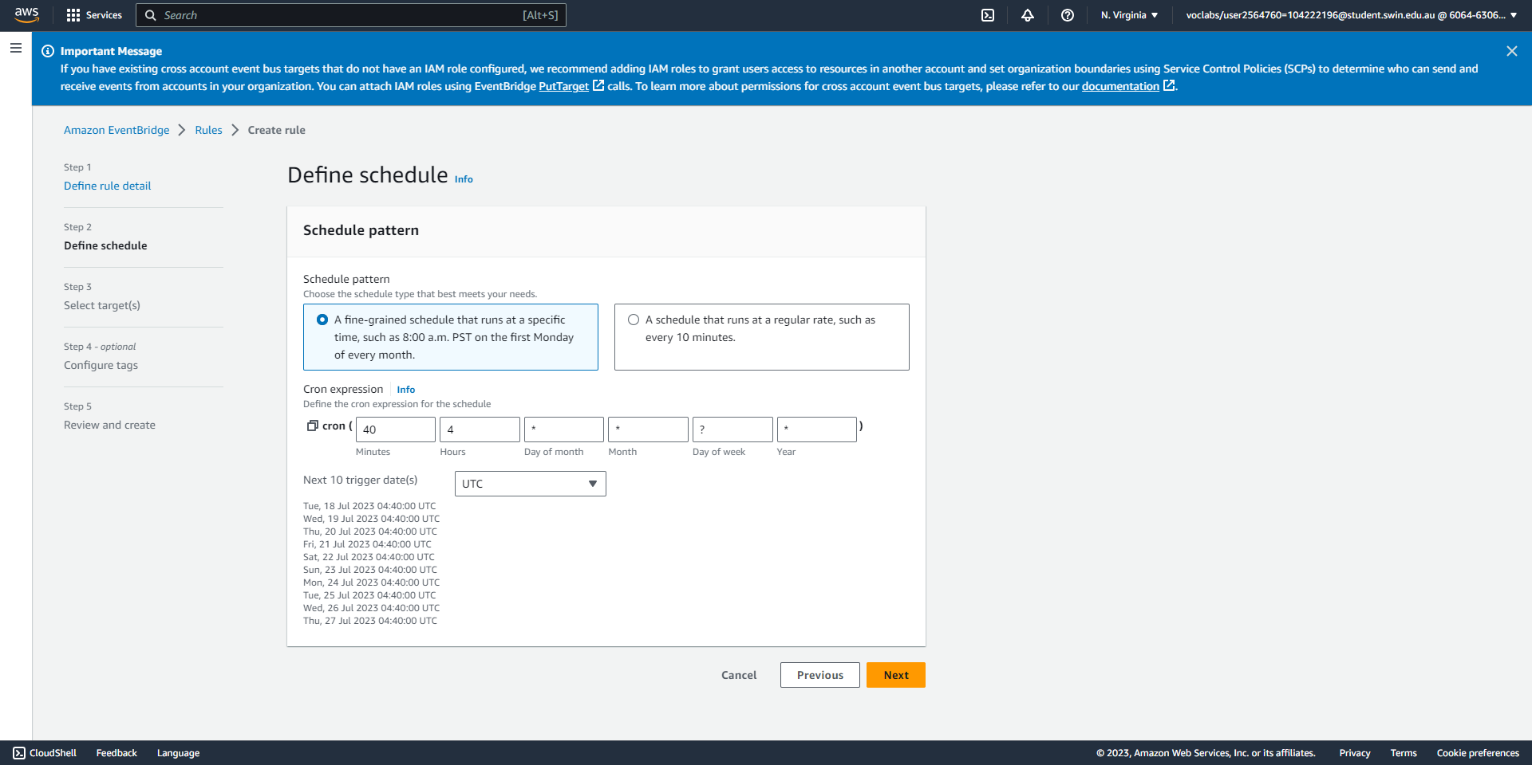



Create an EventBridge event (part 2/3), specifying the schedule pattern with a cron expression that triggers the event at 04:40 A.M. (UTC) every morning.

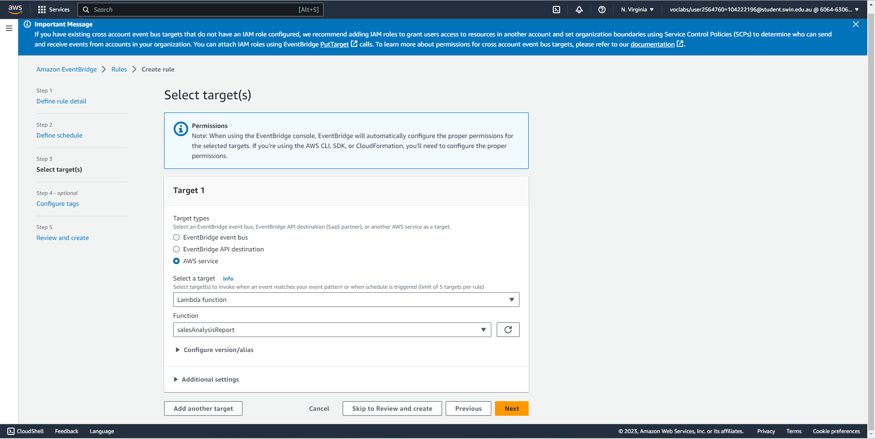



Create an EventBridge event (part 3/3), specifying the target of the event, which is the Lambda function.

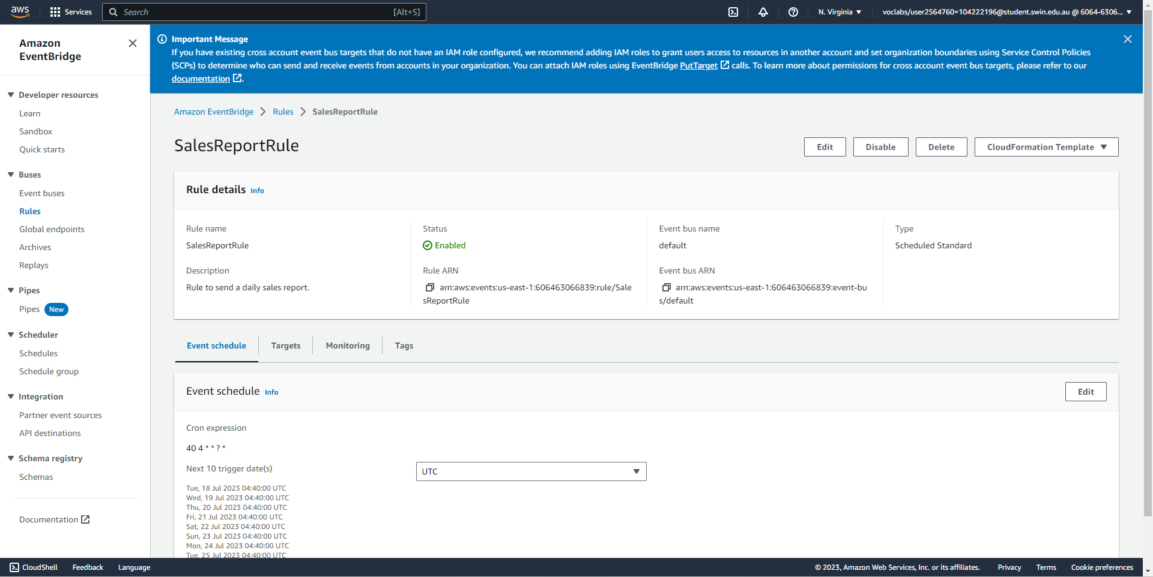

The EventBridge event has been successfully created.

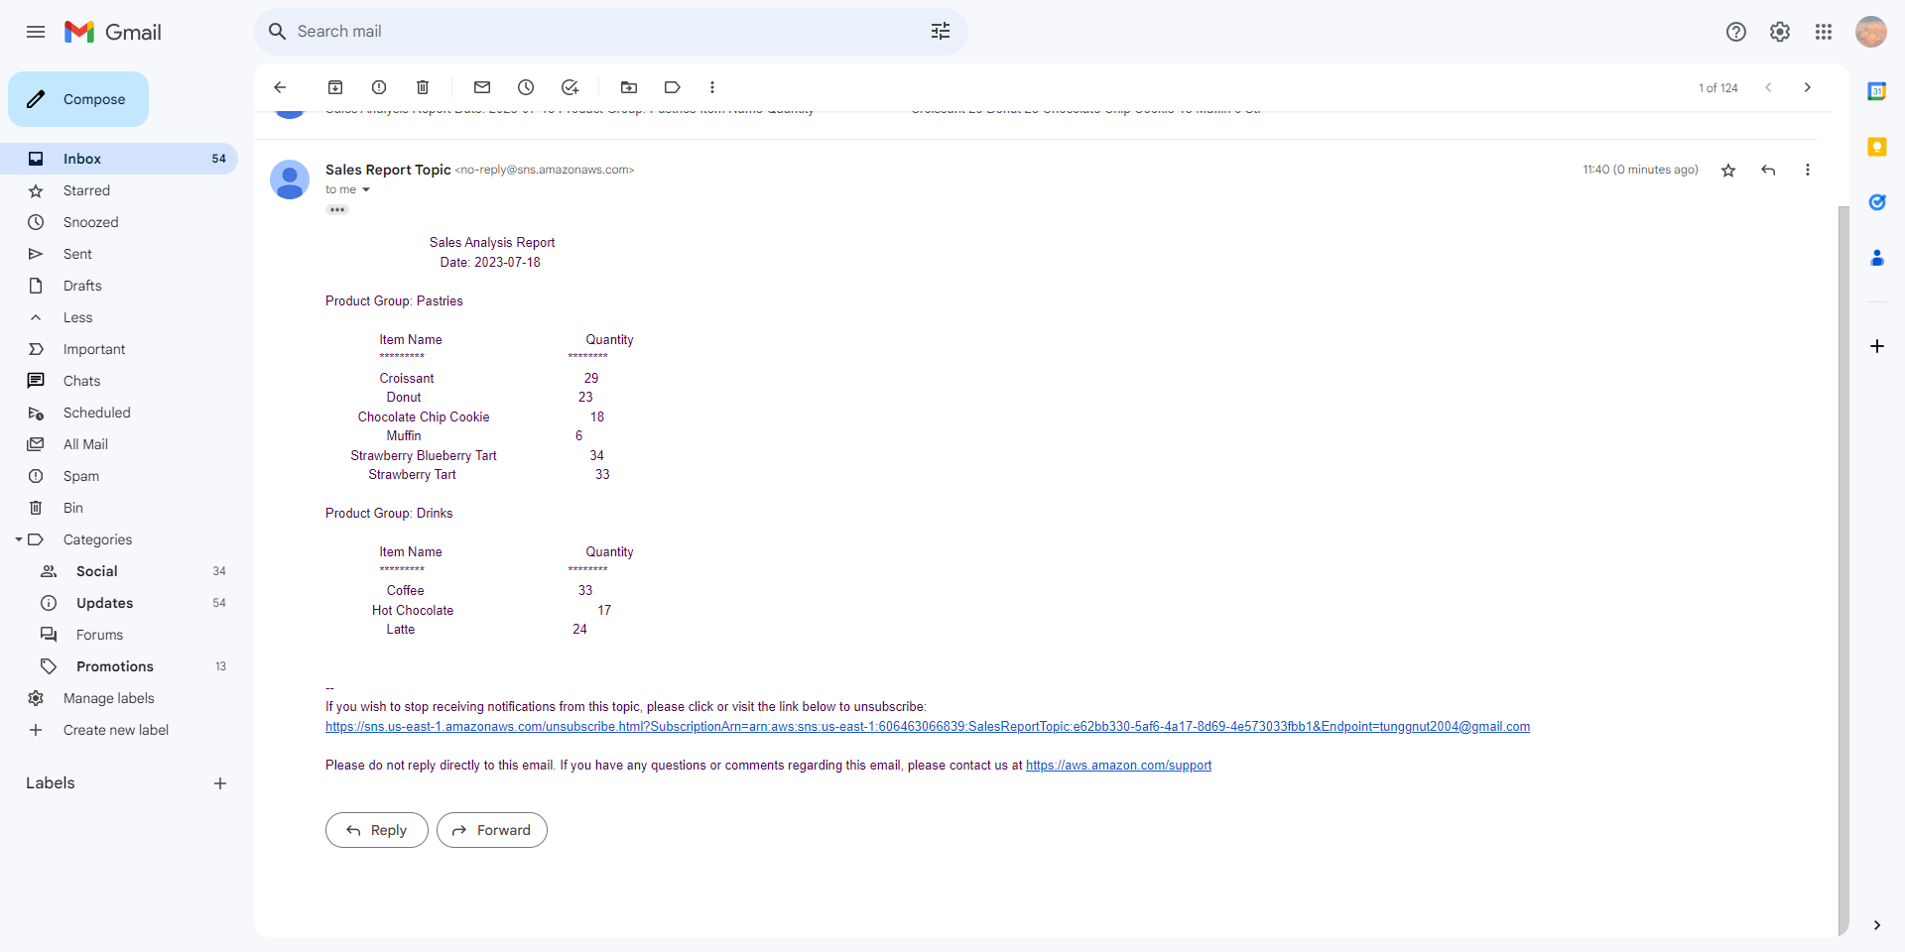



At 04:40 UTC (which is 11:40 GMT+7 in the email), the subscription email receives an email report as expected.